***Digital image processing Lab***

***CEL 444***

***Lab Journal 1***



**Name: Muhammad Saad Afzal**

**Enrollment: 01-134212-212**

**BSCS-7B**

**Department of Computer Science**

**BAHRIA UNIVERSITY, ISLAMABAD**

# **Task # 1:**

**Matrix Addition**

Write a Python program that adds two matrices provided by the user. The program should ask for the dimensions of the matrices and ensure that they have the same dimensions before performing the addition.

Matrix A:

[1, 2, 3]

[4, 5, 6]

[7, 8, 9]

Matrix B:

[9, 8, 7]

[6, 5, 4]

[3, 2, 1]

Matrix A + Matrix B:

[10, 10, 10]

[10, 10, 10]

[10, 10, 10]

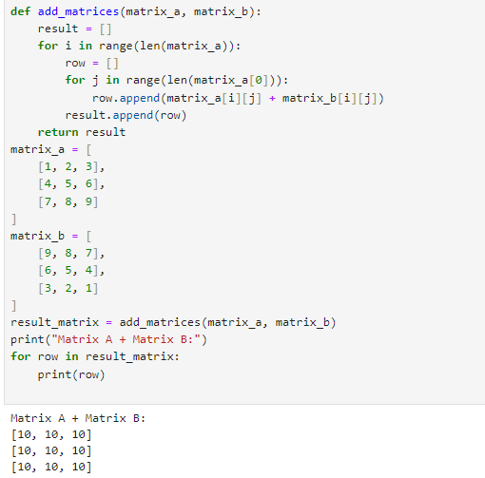

# **Task # 2:**

**Matrix Multiplication**

Write a Python program to multiply two matrices provided by the user. The program should check if the number of columns in the first matrix is equal to the number of rows in the second matrix.

**Example Output:**

Matrix A (2x3):

[1, 2, 3]

[4, 5, 6]

Matrix B (3x2):

[7, 8]

[9, 10]

[11, 12]

Matrix A * Matrix B:

[58, 64]

[139, 154]

